**Making a Difference, One Animal at a Time**

Supporting animals and the people who love them through successful rehoming, and education

[**Donate Now**](https://tlweave2.github.io/friendsofmanteca/donate.html)

**About (FOMAS) Friends of Manteca Animal Shelter**

(FOMAS) Friends of Manteca Animal Shelter is a unique, non-profit organization located in Manteca, CA. We work in partnership with the Manteca Animal Shelter to support animals and the people who love them through successful rehoming, spay/neuter programs, and education.

Our mission is to make a positive impact on the lives of animals in our community through compassionate care, successful rehoming, and educational outreach programs.

[**Learn More About Us**](https://tlweave2.github.io/friendsofmanteca/aboutus.html)

**Meet Our Featured Animals**

These special animals are looking for their forever homes

**Available**

**Ace**

German Shepherd DogYoungMale

Ace is a wonderful dog looking for a loving home.

[**Learn More**](https://tlweave2.github.io/friendsofmanteca/animals.html)



**Available**

**Atlas**

German Shepherd DogYoungMale

Atlas is a wonderful dog looking for a loving home.

[**Learn More**](https://tlweave2.github.io/friendsofmanteca/animals.html)

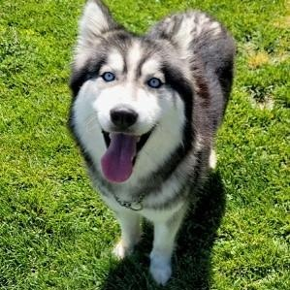

**Available**

**Kaia**

Siberian HuskyYoungFemale

Kaia is a wonderful dog looking for a loving home.

[**Learn More**](https://tlweave2.github.io/friendsofmanteca/animals.html)

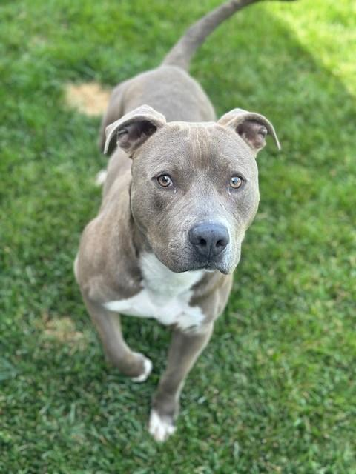

**Available**

**Bruce Wayne**

Pit Bull TerrierAdultMale

Bruce Wayne is a wonderful dog looking for a loving home.

[**Learn More**](https://tlweave2.github.io/friendsofmanteca/animals.html)

[**View All Available Animals**](https://tlweave2.github.io/friendsofmanteca/animals.html)

**🐕 Doggie Day Out (DDO) Program**

Give a shelter dog a break from shelter life! Take a furry friend out for a day of fun and adventure.

🚗

Take a Dog Out

for walks, hikes, or car rides

❤️

Reduce Stress

help dogs decompress from shelter life

📱

Share Photos

help promote dogs for adoption

🏠

Find Homes

increase adoption opportunities

**How It Works**

**1**

Fill out the DDO form

**2**

Visit Manteca Animal Shelter

**3**

Choose a dog and take them out

**4**

Return by 3:30 PM same day

📄 Download DDO Form [**📞 Contact for Info**](https://tlweave2.github.io/friendsofmanteca/contact.html)

**Requirements:** Must be 18+ years old with a valid driver's license or identification. Dogs must be returned by 3:30 PM unless special arrangements are made Our DDO program allows for overnight stays

Bottom of Form

**Support Our Mission**

Join the FOMAS Friends of Manteca Animal Shelter team! There are many ways to help - donate, volunteer, foster, or purchase items from our Wishlist. All support helps us save lives through rehome, spay/neuter programs, wellness care, and education.

[**Get Involved**](https://tlweave2.github.io/friendsofmanteca/get-involved.html)

**Help Save Lives Today**

Your donation directly helps animals find loving homes. Every dollar makes a difference in providing medical care, shelter, and love to animals in need.

[**💝 Donate Now**](https://tlweave2.github.io/friendsofmanteca/donate.html)

[**View All Available Animals**](https://tlweave2.github.io/friendsofmanteca/animals.html)

**Upcoming Events**

[**View All Events**](https://tlweave2.github.io/friendsofmanteca/events.html)

**Our Generous Sponsors**

**Sponsor 1**

**Sponsor 2**

**Sponsor 3**

**Sponsor 4**

**Sponsor 5**

**Sponsor 6**

[@](mailto:info@fomashelter.org)[f](https://facebook.com/fomashelter)[ig](https://instagram.com/fomashelter)

**Mailing Address: 115 E WETMORE, MANTECA CA 95337**

(LEAVE DID NOT MEAN TO STRIKE)**Tax ID#** 33-3577449

[Privacy Policy](https://tlweave2.github.io/friendsofmanteca/privacy-policy.html) | © 2025 (FOMAS) Friends of Manteca Animal Shelter